**AI-Driven Dynamic Fuzz Testing for IoT Security**

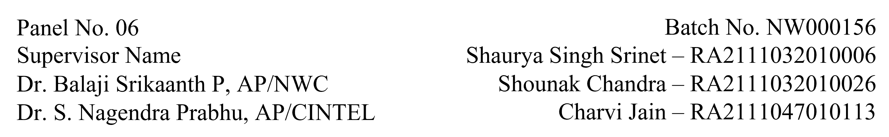

**Functional Document for User Story 3: Train GNN Model for DDoS Detection**

**1. Introduction**

This document outlines the functionality required for training a Graph Neural Network (GNN) model for detecting Distributed Denial-of-Service (DDoS) attacks in IoT network traffic. This is part of a larger AI-driven IoT security project focusing on dynamic fuzz testing and mitigation of cyberattacks.

**2. Product Goal**

The primary goal is to accurately detect and classify DDoS traffic using a GNN model trained on pre-processed datasets generated from IoT network simulations. The model will differentiate between benign and malicious traffic, aiding cybersecurity efforts in real-time threat detection.

**3. Demography (Users and Locations)**

* Target Users Data scientists, cybersecurity analysts, and AI researchers.
* User Characteristics Proficient in network security, AI modelling, and working knowledge of GNNs.
* Location Intended for global use by professionals and researchers involved in cybersecurity.

**4. Business Processes**

* Model Architecture Design
* Define the architecture for the GNN model, considering input features like network traffic flow and topology.
* Implement layers tailored for anomaly detection.
* Model Training
* Use the pre-processed dataset to train the GNN model to recognize DDoS traffic.
* Split the dataset into training, validation, and test sets.
* Model Testing and Saving
  + Evaluate the model on a separate validation dataset to assess its detection accuracy.
  + Store the trained model for deployment and further testing.
* Features
  + Model Training and Evaluation
  + Training process using supervised learning on labelled IoT network traffic data.
  + Validation to ensure the model achieves at least 75% accuracy in detecting DDoS attacks.
  + Utilize cross-validation to ensure robustness.
* Hyperparameter Optimization
  + Various settings tested for optimal model performance such as:
    - Learning Rate
    - Epochs
    - Hidden Layers
    - Batch Size
    - Optimizer
    - Weight Initialization
    - Regularization
    - Activation Functions
    - Loss Function
    - Early Stopping
    - Number of Layers
* Model Saving
  + Save the final model for use in deployment environments, enabling real-time detection.

**5. Authorization Matrix**

|  |  |
| --- | --- |
| **Role** | **Access Level** |
| Data Scientist | Full access to model training and tuning processes |
| Analyst | Access to trained model and its outputs for threat analysis |
| Admin | Full access to system resources and document |

**6. Assumptions**

* The dataset is pre-processed and contains relevant traffic patterns for benign and DDoS scenarios.
* Adequate computational resources are available for training the GNN.
* Model evaluation metrics (accuracy, precision, recall) are pre-defined for validation.

**7. Target Audience**

Audience Data Scientists, AI Researchers, Cybersecurity Analysts.

**8. Effort Estimation**

* Model Architecture Design: 3 days
* Model Training: 5 days
* Hyperparameter Tuning: 7 days
* Documentation: 1 day
* Total: 16 days

**9. Acceptance Criteria**

* The GNN model achieves at least 75% accuracy in detecting DDoS attacks.
* Hyperparameters are tuned to optimize performance.
* The model differentiates between DDoS and benign traffic.
* Training procedures are well documented, and the trained model is saved for deployment.

**10. Checklist**

* Model architecture designed and implemented.
* Dataset pre-processed and ready for training.
* GNN model trained and validated.
* Hyperparameters tuned to optimize detection performance.
* Model saved for deployment.
* Documentation completed.